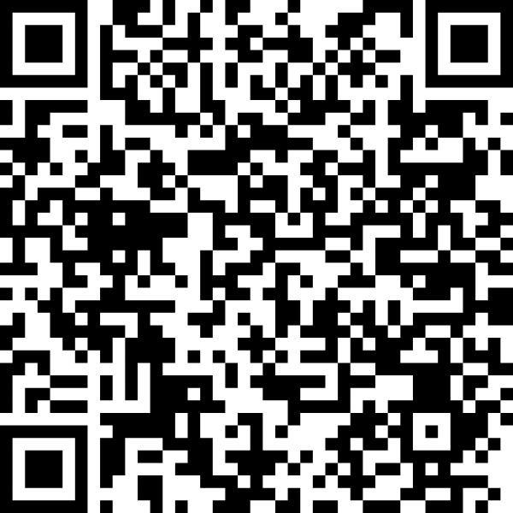
Thank you for your interest in
Scan to
Learn more

A+ Schools of North Carolina.
This letter of interest lets us know you’d like to stay connected as you learn more about A+ and explore whether the approach is a good fit for your school community. Before schools apply, we invite them to take part in two opportunities that offer a closer look at A+ practice:

A+ summer conference observation (summer 2026) Recommended
Schools may send up to three representatives to observe A+ professional development. Reservations must be made by June 30, 2026 to participate.

Pre-application meeting (fall 2026) Required
A session for your team of stakeholders—including the principal—to learn more, ask questions, and begin thinking about how to share A+ information with staff. The principal’s participation is required. In Raleigh on October 29 from 10:00 a.m.–3:00 p.m.
These experiences help your team explore A+, learn alongside us, and consider how the A+ approach aligns with your school’s vision. Should you decide to apply, your school will need to demonstrate that at least 85 percent of certified staff are committed to the A+ process, including attending the five-day A+ summer institute, which will be held in Raleigh July 12–16, 2027.
School name:
Street address:
City, state, zipcode:
Telephone:
District:
Principal’s name:
Principal’s email address:
Principal’s telephone:
To A+ Schools of North Carolina,
By signing below, our school indicates our interest in learning more about A+ Schools of North Carolina and exploring whether A+ is a good fit for our community. We understand that participating in the opportunities listed above will help us gather information, engage our staff, and prepare for thoughtful decision-making about the A+ application process.

Principal’s signature: _____________________________________________________________
Date:___________________________________________________________________________
Please email the completed and signed form to:
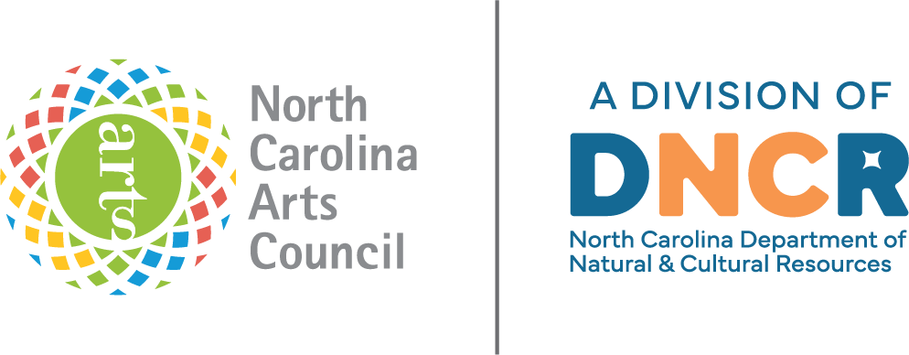
Tom Nevels, A+ Schools Network Director
A+ Schools of North Carolina is a program of the NC Arts Council, a division of the Department of Natural and Cultural Resources
tom.nevels@dncr.nc.gov

