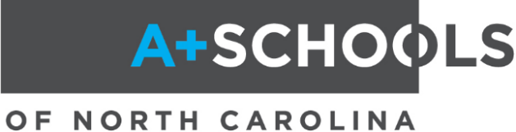
New A+ Schools Process for Network Entry
Summer 2027

So, your school is interested in becoming an A+ school or you know a school that is interested? Below is the process for schools who are exploring the option of entering the A+ Schools network.

A+ Schools of North Carolina is the nation’s longest-running, most successful arts-based whole school transformation model. Newly released research on A+ Schools professional development and implementation demonstrates impressive results in school growth, student proficiency, and narrowing the achievement gap. A+ Schools also helps schools build creative, engaging learning environments that allow students to master the state standards while developing 21st century skills.

Step 1: Letter of Intent
Principals from interested schools submit a Letter of Intent Form by May 29, 2026. This form lets us know that your school is interested in becoming an A+ school and plans to take the necessary steps to find out more about joining the A+ network. Letter of Intent Forms may be found on the A+ website.

Step 2: A+ Summer Conference Observation
Interested schools who have submitted a letter of intent for 2027-2028 entry may send up to three leaders from their school to observe a day or two of our summer conferences during the summer of 2026. Observers should include the principal and could also include a district representative or other key leaders/teachers at the school who would be responsible for sharing information with your whole staff. RSVPs are required to observe during our summer conferences. Please contact A+ Schools Program Coordinator Jennifer Huggins at jennifer.huggins@dncr.nc.gov to reserve a spot.

Step 3: Pre-application Meeting
Interested schools will send a team of representatives to a mandatory pre-application meeting in October/November of 2026, meeting date TBD. This meeting will provide more information on what it means to be an A+ school, look deeper into A+ processes, and allow time for Q&A with A+ staff and A+ Fellows. School teams must include the principal, and teams may include district representatives and/or teacher leaders from each interested school. Schools that have submitted a Letter of Intent Form will receive an invitation and registration information for this event by email in September 2026.

Step 4: Sharing Information and Gaining Staff Commitment
Representatives from the interested schools who have observed at a summer conference and/or attended the pre-application meeting will share what they have learned with the rest of their staff, along with the dates of the A+ Schools 5-day Summer Institute that your school would be required to attend in 2027. Each school then surveys their staff and secures a minimum of 85% faculty commitment indicating becoming an A+ school is the right fit for the school and the staff wants to join the A+ Schools network. A+ staff are available to answer questions and offer support as needed throughout this process.

Step 5: Application
Once 85% commitment has been obtained by the staff, schools may submit an application to become an A+ school (the application is available on our website). Applications are due no later than Friday, December 4, 2026, at 5 p.m. and require several letters of support and signatures. Schools will be notified of acceptance by December 18, 2026.

Step 6: Getting Ready
Spring 2027 will allow time for each school to prepare for their first A+ professional development with opportunities for school leadership to attend A+ Leadership Meetings and pre-arranged visits to several A+ schools.

Step 7: Attending the 2027 A+ Summer Institute
New schools will attend five days of A+ training in Raleigh during the summer of 2027. The tentative dates for the 2027 A+ Summer Institute are July 12-16, 2027, in Raleigh. A minimum of 85% of each school’s certified staff plus the administrative team is required to attend. All staff, as well as district representatives, parent leaders, and other school stakeholders, are also invited to attend. Details and registration for the 2027 Summer Institute will be available in the spring of 2027.

For more information about A+ Schools of North Carolina, please visit our website at
https://www.ncarts.org/arts-council-z/aplus-schools-nc or contact Jennifer Huggins, A+ Schools Program Coordinator: (919) 814-6520 or jennifer.huggins@dncr.nc.gov.

GET CONNECTED WITH A+
Web: https://www.ncarts.org/arts-council-z/aplus-schools-nc
Facebook: http://www.facebook.com/aplusnc
Live Binder: http://www.tinyurl.com/apluslb
Access code: A+NCNetwork

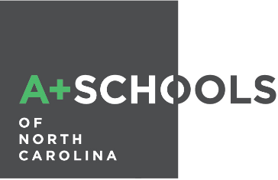

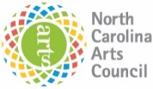
A+ Schools of North Carolina is a program of the N.C. Arts Council, an agency of the Department of Natural and Cultural Resources

