**Study Description:**

This mixed methods study explored teacher vacancies at A+ schools, student achievement and academic growth and A+ educator job satisfaction. Friday Institute researchers designed and distributed a survey, conducted school site visits, analyzed publicly available teacher vacancy data for A+ Schools and collaborated with 18 A+ educators in a year-long photovoice project.

**Key Finding 1: In 2022-2023, A+ Schools had fewer Day 1 vacancies than their LEA counterparts.** In our annual administrative survey, 60% of A+ administrators reported non-troubling day 1 vacancies. A comparison of Day 1 vacancies between A+ schools and their district averages support the survey finding: A+ Schools tend to have a lower percentage of teacher vacancies.

**Key Finding 2: In 2022-2023, 77% of A+ Schools exceeded or met growth.**  In 2022-2023, 77% of A+ Schools exceeded or met growth. The numbers are even more encouraging when we break it down in terms of grade bands. NC A+ elementary schools that served pre-kindergartners (PK) along with traditional elementary grades met or exceeded growth at 84%. In terms of academic proficiency, NC A+ schools continued to do as well, and in some instances, better than their non-A+ counterparts.

**Key Finding 3: A+ Educators distilled 4 crucial components of their job satisfaction.** During the 2023-24 school year, educators collected and analyzed artifacts that illustrate what it **feels** like to be an educator at an A+ school. **Agency** captures educators' autonomy within the A+ model, allowing them to act on their artistic visions, take pedagogical risks, and innovate in alignment with their teaching philosophy. It also reflects the importance of being recognized by peers, students, and the school community, with enriched assessments playing a smaller role. **Alchemy** represents educators’ ability to blend creativity, cross-disciplinary collaboration, and innovation, transforming challenges into engaging learning experiences. This “superpower” highlights the joyful, hard work of A+ educators. **Legitimacy** underscores the validation of educators' expertise and the model’s coherence. When consistent, it fosters trust and satisfaction; when disrupted, it can lead to disillusionment. **Legacy** centers on educators’ lasting contributions through the arts, like murals or performances, that offer a tangible representation of their creativity, collaboration, and pride, deepening their connection to the school community.

*“I hope that we can use these [crucial components] as a guide –who and how we hire, decisions we make as a school around professional learning and priorities, and how we monitor our A+ engagement.”*

*-A+ educator/ co-researcher*

**Implications:** In 2021-2022 educators in A+ Schools expressed high levels of enthusiasm about the support they received, with many noting that working in an A+ School was meaningful and rewarding. We also learned that A+ Schools may have outperformed their PSU counterparts in teacher retention and support during the Covid-19 pandemic. We felt that it was crucial to explore how the A+ model contributes to fostering positive working conditions for teachers. 2022-2023 findings support previous findings; A+ schools have on average fewer vacancies and educators at engaged A+ schools experience high levels of work satisfaction. A+ educators/co-researchers distilled four crucial components of work satisfaction that should be leveraged by A+ organizational and school level leadership.

**How Does It Feel to Work in A+ Schools?**

**Emerging Themes from NC Educator Perspectives**

From our multimodal analysis, we identified four key themes that capture **what matters most for educators at A+ schools regarding their job satisfaction**. These themes are agency, alchemy, legacy, and legitimacy. Each of these elements represents a crucial component of what drives and sustains the commitment and satisfaction of educators in these institutions.

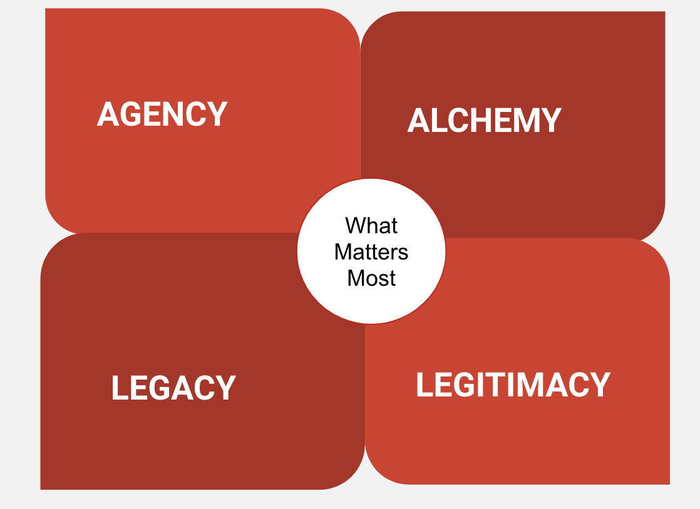

**Agency** captures the sense of autonomy that educators experience, especially in the best-case scenarios within the A+ model. It goes beyond simply being empowered to make decisions; it includes the freedom for educators to act on their own artistic visions, to take pedagogical risks with the well-being and happiness of students in mind, and to innovate in ways that resonate with their personal teaching philosophy. This theme also reflects the importance of being "seen"—of having their efforts recognized and valued by their peers, students, and the school community. To a lesser extent, agency can also be traced to times when A+ educators lean on enriched assessments to meet student comprehensive needs and participate in leadership opportunities within the A+ model.

**AGENCY**

**Examples**: Serving as A+ Coordinator, serving as an A+ Fellow, collaborations with visiting artists; leading community-based student exhibitions; planning or initiating change in a whole school or grade level initiative; running a club based on own artistic interests/curiosities; being celebrated and part of “A+ ish” celebrations for colleagues; being encouraged to choose Professional learning opportunities, timing, etc.

**Counter Examples:** feeling thwarted by colleagues/administrators when wanting to try a new ‘thing’; being provided ‘model’ or ‘scripted’ lessons; misaligned teaching evaluations; not being trusted as a classroom expert and not being provided with meaningful arts-integrated informed feedback

**Guiding Question:** Where do I see AGENCY in my school? Where can I leverage into this crucial component more meaningfully?

**Alchemy** represents what A+ educators portrayed as a dynamic blend of creativity, cross-disciplinary collaboration, and innovative thinking used to transform everyday challenges into extraordinary learning experiences. It highlights their ability to work across different subjects and areas of expertise, turning the “mundane” aspects of education into “magnificent” opportunities for student growth and engagement. Alchemy was emphasized as an A+ educator superpower, and a recognition of their joyful, oftentimes hard, work.

**ALCHEMY**

**Examples:** one school-one book; concrete examples of alchemized lessons emerged including multiple examples ofdance through and with math standards, theater arts with and through science standards, music with and through language arts standards, place-based lens (e.g., focus on region)

**Counter Examples:** Infrastructure barriers, rapidly changing student enrollment numbers, rigid rules about paperwork, progress monitoring and testing from district and state level; hiring processes that do not clearly reflect A+ way; close minded mindset from leaders and educators.

**Guiding question:** Where do I see ALCHEMY in my school? How can I leverage this crucial component more meaningfully?

**Legitimacy** emphasizes the recognition and validation of educators' expertise and contributions within the A+ model. It also highlights the importance of the model’s legitimacy, achieved through coherence and consistency. When the model is applied effectively, educators feel valued and respected, with their work being supported by a stable and reliable framework. However, the significant impact of legitimacy on teacher satisfaction is especially evident in counterexamples where the dropping of programs, rituals, or spaces can disrupt the sense of continuity and undermine the educators' trust in the model. Such inconsistencies can lead to feelings of disillusionment, making the coherence of the model crucial for sustaining educators' confidence and satisfaction.

**LEGITIMACY**

**Examples:** Family and community engagement; physical space reflects A+ vision “more than a banner”; makerspace or room of props for teachers to source creativity; public memory of arts-integration/experiences; regular A+ grounded discussions in faculty meetings/PLCs, advocacy at the district level; leadership/presence in the wider community; experiential Professional Learning with whole staff; being willing to have frequent hard discussions about long term vision for A+ in our school

**Counter Examples:** Administrator misunderstands A+ model, over emphasis on final product (e.g, show) rather than experience; dropped programs or neglected spaces; not being a participant in A+ opportunities, meetings, leadership network, A+ classrooms

**Guiding Question:** Where do I see Legitimacy in my school? How can I leverage this crucial component more meaningfully?

**Legacy** centers on the tangible, lasting contributions that educators make through the arts. It reflects the collective pride teachers feel in having created something enduring—whether it's a mural, a performance, or any physical representation of their work with students. This theme underscores the importance of leaving behind a concrete legacy, a visible testament to the creativity, collaboration, and effort that defines their teaching journey. The sense of having co-crafted "something" that lasts gives educators a deep sense of fulfillment and connection to their school and community. Legacy could be traced to the transformation of physical spaces as well (e.g., annual rituals to memorialize cohorts).

**LEGACY**

**Examples:** Cohort graduation gifts to school (e.g., sculptural birds; painted ceiling tiles;

textile arts in shared spaces); public/community facing performances; school hallways

treated like actual art galleries; living’ spaces that regularly transform based on student

experiences.

**Counter Examples:** tokenized/“cookie cutter” projects; guidelines about

displaying only “perfect” or formalized work; no reflection following experiences; not enough experiential opportunities.

**Guiding Question:** Where do I see LEGACY in my school? Where can I leverage this crucial component more meaningfully?