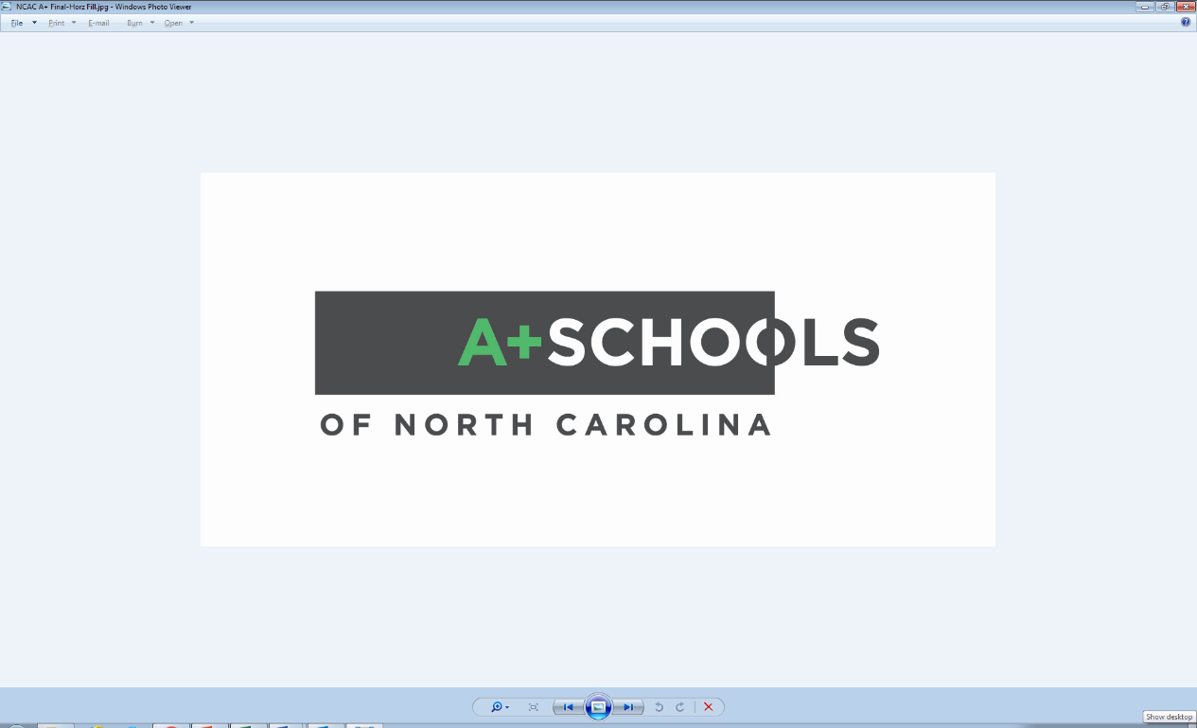

*Since 1995, A+ Schools has used the arts to teach all subjects, transforming schools into more engaging, meaningful and enjoyable places to teach and learn.*

A+ Schools of North Carolina is a whole-school, arts-based educational initiative housed at the North Carolina Arts Council. A+ schools teach the state’s mandated curriculum in a collaborative, multi-disciplined way, with the arts woven into every aspect of a child’s learning. Through professional development, technical support and mentoring, each A+ school develops a unique school identity that enhances the educational experience to prepare students for the challenges of tomorrow’s creative and global economy.

In addition to serving a network of more than 50 schools statewide, A+ collaborates with NC Department of Public Instruction, NCCAT, and other partners in the field of education to train teachers to integrate the arts into their classroom practice. One example of training offered to teachers beyond the network is a STEAM-based (science, technology, engineering, art, and math) teacher institute offered each summer for educators from rural counties in eastern NC.

**A+ Schools Fast Facts:**

* Nationally recognized as a leader in arts-based, whole school transformation.
* Established in NC as a public/private partnership in 1995.
* Serves more than 30,000 students statewide each year.
* Meets NC Department of Public Instruction accountability standards.
* Research-based initiative with sustainability and long-term results due to three factors: high-quality, on-going professional development; the use of arts to teach all subjects; and a statewide support network for teachers and school administrators.

**Recent research shows that:**

* A+ Schools increases overall school performance. Following the initial three years of implementation, schools meet growth goals.
* A+ students gain proficiency. The number of students achieving grade-level proficiency increases substantially as students experience A+ implementation.
* A+ narrows the achievement gap. Students who are traditionally the most marginalized, show the largest and quickest gains in student achievement following implementation.
* There is a positive cumulative effect on student growth and achievement with prolonged A+ engagement. In other words, the more years that a school actively engages with A+ the stronger the achievement of its students.