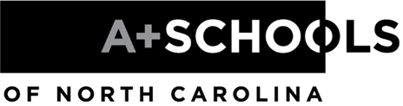
LETTER OF INTENT
Due Date: Thursday, June 1, 2023, by 5 p.m.

Becoming an A+ school requires faculty commitment and a clear understanding of the process. In order for schools to develop this understanding, A+ Schools of North Carolina offers two opportunities to learn more about our program prior to submitting an application:

- A+ Summer Conference Observation, Summer 2023
An opportunity for a small team from a potential A+ school to observe A+ professional development in action.

- Pre-Application Meeting: Friday, October 27, 2023, for five to seven school stakeholders, including the principal. (Principal attendance is required at this meeting.) Attendees will learn more about A+ Schools as they consider how to share their new knowledge with and gain commitment from their staff.

To A+ Schools of North Carolina,

Please accept this Letter of Intent as an indication of our interest in potentially entering the A+ Schools network. We understand that in order to be considered as a potential A+ school, we must demonstrate that 85% of our certified staff is committed to the A+ process, including attending a five-day A+ Summer Institute in 2024. We will investigate the benefits of being an A+ school and clarify our interest in joining the A+ network prior to making application. We understand that A+ Schools offers opportunities as listed above so that we can educate our staff and make an informed decision about whether A+ Schools is a good fit for our school. Please send acknowledgement and further details to the email address below.

School Name:
Street Address:
City, State, and Zip:
Telephone:
Fax:
District:

Principal’s Name:
Principal’s Email Address:
Principal’s Telephone:

Principal’s Signature:
Date:

Please email the completed and signed form to:
Michelle Burrows, Director, A+ Schools of North Carolina
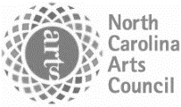
email: michelle.burrows@ncdcr.gov

A+ Schools of North Carolina is a program of the N.C. Arts Council, an agency of the Department of Natural and Cultural Resources

