
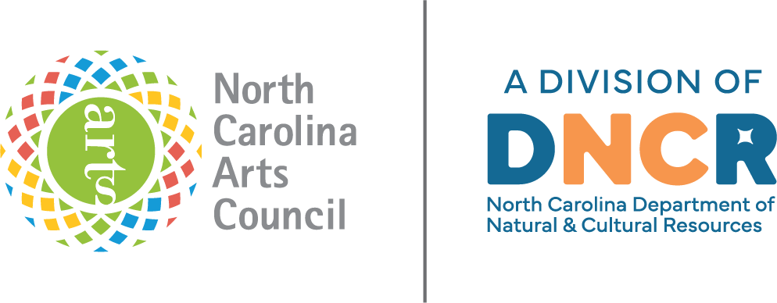

Last Updated January 2026

North Carolina Arts Council

Artist

Support

Grant

Guidebook for

Regional Partners

Artist Support Grant Overview
The North Carolina Arts Council Artist Support Grant is a regional grant program to support individual artists in all phases of their career. The program funds professional and artistic development for emerging or established artists to create work, improve their business operations, or bring their work to new audiences.
The grant is administered by 18 regional consortiums to serve artists in rural and urban areas across the state. The Artist Support Grant Resources page provides local arts council partners with access to this guidebook and additional resources.
Staff contact:
Leigh Ann Wilder
Senior Program Director, Creative Economies
(919) 814-6508
Leighann.Wilder@dncr.nc.gov

Artist Support Grant Regions
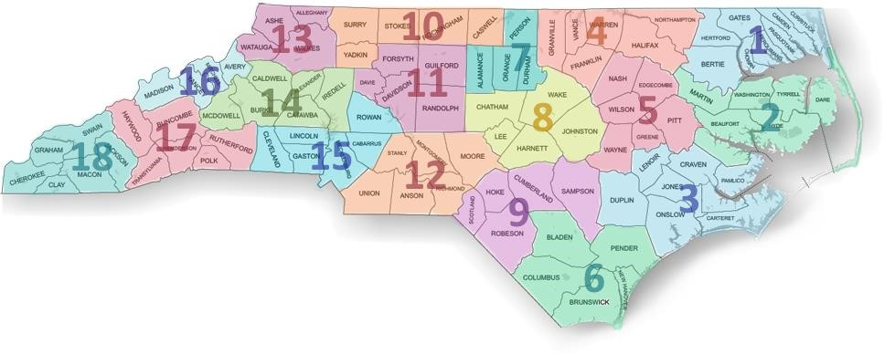
1: Bertie, Camden, Chowan, Currituck, Gates, Hertford, Pasquotank and Perquimans Counties
2: Beaufort, Dare, Hyde, Martin, Tyrrell and Washington Counties
3: Carteret, Craven, Duplin, Jones, Lenoir, Onslow and Pamlico Counties
4: Franklin, Granville, Halifax, Northampton, Vance and Warren Counties
5: Edgecombe, Greene, Nash, Pitt, Wayne and Wilson Counties
6: Bladen, Brunswick, Columbus, New Hanover and Pender Counties
7: Alamance, Durham, Orange and Person Counties
8: Chatham, Harnett, Johnston, Lee and Wake Counties
9: Cumberland, Hoke, Robeson, Sampson, Scotland
10: Caswell, Rockingham, Stokes, Surry, and Yadkin Counties
11: Davidson, Davie, Forsyth, Guilford, and Randolph Counties
12: Anson, Montgomery, Moore, Richmond, Stanly and Union Counties
13: Alleghany, Ashe, Watauga and Wilkes Counties
14: Alexander, Burke, Caldwell, Catawba, Iredell and McDowell Counties
15: Cabarrus, Cleveland, Gaston, Lincoln, Mecklenburg and Rowan Counties
16: Avery, Madison, Mitchell and Yancey Counties
17: Buncombe, Haywood, Henderson, Polk, Rutherford and Transylvania Counties
18: Cherokee, Clay, Graham, Jackson, Macon and Swain Counties

Eligibility and Scope
The Artist Support Grant is intended to support a broad range of talented artists in the genres of visual arts, performing arts, literary arts, music composition, choreography, and interdisciplinary arts. Eligible candidates may be either emerging or established artists. Applicants should demonstrate a commitment to spending a significant portion of their time on their work as artists.
Individuals and Artist Collectives — Both individual artists and small, unincorporated groups of collaborating artists are eligible to apply.
Residency — Artists should have lived continuously in the region in which they are applying for at least one year prior to the consortium’s application deadline. An applicant must be at least 18 years old and either a U.S. citizen or a permanent resident alien. The consortium may require proof of residence and status. Artists who live in more than one region should apply only where they spend most of the year.
All members of a collaborating team must be North Carolina residents, live in the region in which they are applying, and meet the other eligibility requirements.
Résumés for all team members documenting residence should be included with the application.
Multiple Awards — Artists who are sole proprietors of organizations that have already received funding for the current fiscal year from the N.C. Arts Council are ineligible to apply. Awardees must also wait at least two years after the award year before becoming eligible to reapply.
Conflict of Interest — Current board and staff members of the consortium partner organizations and their immediate family members are not eligible to apply.
Student Status — The Artist Support Grant is intended for adult, nonstudent artists. Artists enrolled full-time in undergraduate or associate degree-granting programs may not apply for the grant. Artists in certificate programs are generally eligible. Artists pursuing graduate degrees in subjects other than their art form may be eligible if they meet the other eligibility criteria. Other questions and special circumstances should be discussed with N.C. Arts Council staff.
Grant Guidelines.

Eligible Projects and Costs
Applicants may apply for up to 50 percent of the grant to support artist fees.
- Completion/Presentation of a New Work — Cost of resources necessary to complete or present a significant new work (e.g., purchasing art supplies or equipment (digital may qualify) or space rental)
- Career Promotion — Projects aimed at advertising artists’ work and/or demonstrating their skill level (e.g., websites, portfolios, audio-visual documentation, and online presentation)
- Training — Costs to attend a class or workshop (in-person or virtual) aimed either at enhancing the artist’s skill level or professional development (e.g., a master class or workshop taught by acknowledged authorities in the applicant artist’s medium)
- Travel — Costs of transportation, lodging, and food for training, professional conferences, or research as allowed or possible while adhering to social distancing guidelines

Ineligible Projects and Costs
- Scholarships for undergraduate- or graduate-level education
- Projects that support or oppose a particular candidate for public office
- Projects that are exclusive to members of a particular religious faith group
- Nonprofit initiatives
- Projects that do not have a direct effect on the applicant’s growth as an artist (e.g., the promotion of other artists’ work)

Evaluation Criteria

Artistic Merit
- Demonstrated talent in an art form and overall excellence of the artist’s work
- Clear commitment to a career as a practicing professional artist

Project Merit
- Benefit of the proposed project to the artist’s professional growth
- Feasibility of the proposed project
All complete applications will be reviewed by a panel of arts professionals with experience in various disciplines. Panelists will score each application based on the above evaluation criteria.

Grant Timeline
Grant promotion | July-August
Workshops/training (may be virtual) | July-August
Panels | September-November
Applicants notified of panel decisions  Awardees are issued payments | November-December
Consortiums announce the awardees | January
Connect with artists to make sure projects are progressing | April-June

Roles and Responsibilities
Each consortium has an arts council that serves as lead for the Artist Support Grant program. Duties of the lead arts council include:
- Completing the grant application and final report for the N.C. Arts Council
- Coordinating consortium planning meetings
- Distributing guidelines and grant materials to the consortium
- Coordinating marketing efforts with regional consortium members
- Cultivating partners to promote the opportunity to previously under- engaged communities, such as communities of color, disability communities, rural communities, economically disadvantaged communities and other underserved communities
- Providing assistance and resources to interested applicants
- Recruiting and orienting panel members
- Facilitating panel meetings
- Maintaining communication with N.C. Arts Council staff
Although the consortium members may have fewer administrative responsibilities, their investment is critical to the program’s success. Their responsibilities include:
- Participating in consortium planning meetings
- Participating in promotion efforts for the grant
- Cultivating partners to promote the opportunity to previously under- engaged communities, such as communities of color, disability communities, rural communities, economically disadvantaged communities and other underserved communities
- Helping potential applicants in their county
- Accepting applications, if necessary
N.C. Arts Council staff will provide guidance, training, and a variety of online resources and tools to help each region administer the grant and make this funding opportunity available to as many artists as possible. N.C. Arts Council responsibilities include:
- Providing guidance to regional partners to help them complete the application and final report to the N.C. Arts Council
- Providing grant orientation and training for each region, as needed
- Providing or attending applicant workshops to answer questions
- Assisting with grant panel recruiting and orientation, as needed
- Observing grant panel meetings
- Maintaining communication with regional partners

Communicating with Artists
Participating arts councils should ensure that the following information is made available to potential applicants:
- Brief description of Artist Support Grant
- List of local arts councils or other county partners in consortium
- Project period for the grant and application deadline
- Eligibility requirements, grant guidelines, and selection criteria
- Maximum allowable request and typical range of awards
- Availability of grant workshops or webinars or other online resources
- Contacts for more information or assistance

Publicizing the Grant Opportunity
The lead arts council will distribute a sample press release to the consortium members. The N.C. Arts Council recommends that consortia promote the opportunity using websites, email, newsletters, postcards, and social media platforms at least six weeks prior to the deadline.

Community Outreach
Each consortium should also coordinate efforts to connect with partners who can assist with reaching artists and organizations of under-engaged communities, such as communities of color, disability communities, rural communities, economically disadvantaged communities, and other underserved communities who may be eligible for the grant.

N.C. Arts Council Logo Use and Recognition
When publicizing the Artist Support Grant, a consortium must recognize the N.C. Arts Council as the primary award sponsor. Any promotional materials related to the grant must contain the N.C. Arts Council credit line and logo. Standards and logos can be found on our website on the Logos and Branding page.
Consortiums that have cultivated other significant funders should list those funders as supporting sponsors.

Applicant Assistance
Each consortium member is responsible for offering support to applicants. At a minimum, prospective applicants should be informed that they may contact their local arts council for advice over the phone or by email. Individual consultations are recommended to help artists develop stronger proposals. If a county cannot offer staffing or support, applicants should be directed to contact the lead arts council with questions. Consortia are also encouraged to offer workshops or webinars for interested artists prior to the application deadline.

Panel Review Process
Consortium members collaborate on the recruitment of applicants and facilitate the selection process, but the review of applications must be conducted by professionals qualified to evaluate the merit of the work and projects submitted. This is both to ensure that deserving artists are selected and that organizers do not face conflict of interest situations by participating in the decisions. The N.C. Arts Council has created the following guidelines for the evaluation process as the basis for the Artist Support Grant panel review.

Selecting Panelists
Knowledge and Expertise: Panelists should be chosen based on the art forms submitted in the grant cycle. Examples of categories of people who are qualified to serve effectively are professional artists (including N.C. Arts Council fellowship recipients or previous Artist Support grant award recipients), college and university professors in creative arts disciplines, museum directors and curators, theater managers and directors, musical directors, composers, choreographers, etc. Using professional panelists brings credibility and prestige to the process.
Avoiding Judges and Panelists with Financial Interests: As a rule, artist agents, gallery owners, book publishers, and other professionals with a financial interest in artists and their work are not recommended to serve as judges or panelists because of potential conflicts of interest.
Residency: While qualified representation from partner counties is ideal, panelists do not have to be from the consortium region. Consortiums may recruit panelists from outside of their counties and region, especially if in some disciplines there are no concentrations of artists and arts specialists in the area.

Equitable Representation: Panelists should be racially representative of the region being served and their terms of service should be limited to no more than two years, to allow for a regular rotation of people with different backgrounds and perspectives. The demographics of the consortium region should be reflected in the panelists selected.
Compensation: It is recommended that panelists are paid for their time and expertise, and at a minimum to reimburse them for any travel expenses. Even a modest honorarium or mileage stipend recognizes their investment to help the local arts council and artists in the region.
Conflicts of Interest: Members of the panel should declare potential conflicts of interest and discuss them in advance with the consortium coordinator. If a potential conflict of interest arises, the panel member must disclose it and should not vote on or participate in the discussion pertaining to that applicant. A panelist with a conflict should leave the room during the discussion to avoid influencing the deliberations.
Role of Local Arts Council Staff and Board: Staff or board members should not participate as voting members of the review process. To do so compromises their ability to advise artists on their applications.
Local arts council staff involved with running the panel meeting(s) should be familiar with the applications and be able to provide clarifying information if the panel is unclear about or misreads a proposal. While being careful not to advocate for artists under consideration, they are responsible for seeing that each proposal gets a fair and thorough review.

Running the Artist Selection Process
Scoring: Applications are rated on three criteria: artistic merit, project feasibility, and contribution to development of the artist’s career.
Discipline-specific panels generally rate artistic merit first. This establishes a natural cutoff for funding. Project feasibility and contribution to the development of the artist’s career is then scored for the highest-ranking applications. We recommend using a five-point scale.
[Sample application rating sheet is available on the Artist Support Grant Resources page]
The NC Arts Council has provided scoring and tabulation sheets to determine final scores and help with funding decisions. A template can be accessed below. The Excel spreadsheet is useful for calculating final scores. In the tabulation sheet, the artistic merit score is weighted twice, because it must have the highest priority.
[Sample scoring and allocation tabulation sheet is available on the Artist Support Grant Resources page]

Artist Selection with Discipline-Specific Panels
Step 1: Discipline panels offer the opportunity to assess applications using professionals familiar with the art forms. This process not only provides a solid review of artistic merit but also funnels the best applications for final review.
Discipline panels may recommend full or partial funding and should identify those applications they feel merit consideration for final review.
*Step 2: In some regions, a second panel conducts the final review. In this case, artistic merit has been established so the focus can shift to a project’s feasibility and contribution to the artist’s professional development. Typically, this second panel includes one member of each discipline panel and may be supplemented by other professionals, with each application scored on the approved scale.
*In some regions, both steps are combined in a single panel process.
Recording of Comments: Local arts council staff should compile panel members’ comments to provide constructive feedback to applicant artists. It is especially helpful for artists to know what issues in their proposals concerned panelists. When staff share comments, their emphasis should always be on observations that can help artists improve how they present themselves and their work.
Awards: Consortiums should establish maximum and minimum award amounts and include this information in the guidelines. We strongly recommend that awards not fall below $500. The consortiums have discretion to offer a higher amount when a project merits this and the budget allows. However, larger awards should not be made at the expense of funding a representative percentage of applicants.

Full vs. Partial Funding: While full funding of all applications is desirable, budgets often do not allow for this outcome. As a result, proposals may be recommended at less than the full amount. In such a case, the artists should be given the option of accepting the award and submitting a revised budget or turning it down. If an artist declines an award, the funds can be redistributed among other partial grantees or allocated to the next artist in the rating order.

Communicating Results

Guidelines for Award Letters
All artist recipients should be sent a letter congratulating them on their awards. The letter should make clear that the grant is made possible with funding from the N.C. Arts Council. The letter may double as a contract spelling out the terms of the grant, or a separate award contract may be enclosed.
[Sample award letter and contract are available on the Artist Support Grant Resources page]
Artists who receive Artist Support Grants should be recognized in traditional and electronic media. Guidance and boilerplate copy can be found on our website on the Logos and Branding page.

Notifying Artists Who Did Not Receive an Award
Notifications to artists who were not awarded a grant should be made with respect and sensitivity. Each artist should receive a diplomatically worded letter that covers the following points:
- Evaluation criteria
- Number of applications, total amount requested, and overall budget for the awards
- Invitation to contact staff for feedback
[Sample rejection letter is available on the Artist Support Grant Resources page]

Managing the Awards and Projects

Artist Grantee Requirements

Contract and Grant Disbursal
The grant contract spells out the terms of the award. It should include the following information:
- Project grant amount
- Payment schedule
- Reporting requirements
- Purposes of the award
- Project and granting period
- N.C. Arts Council credit line and logo requirements
- Other specific requirements or stipulations of the consortium
Both the grantee artist and a consortium representative should sign the contract before money is transferred. Any subsequent changes to the agreement should be in writing. If an artist has been awarded an amount significantly less than requested, the consortium should require the artist to submit a revised project budget, to assure that the project can still be implemented. [A customizable sample grant contract is on the Artist Support Grant Resources page]

Artists should sign and return their letters/contracts before the lead arts council issues award checks. Projects should be completed within a year from the start date.

Reporting Requirements
Each artist receiving an award will be required to provide a final report at the conclusion of the funded project, and no later than thirty (30) days after the grant period ends. . [A final report form template is available on the Artist Support Grant Resources page]

