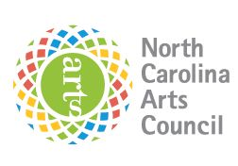**North Carolina Arts Council Artist Support Grant**

**Sample Grant Rejection Letter**

**[ include LAC Logo ]**

[Date]

[Full Name]   
[Address Line 1]  
[Address Line 2]

Dear [Name]:

Thank you for your application to the North Carolina Arts Council Artist Support Grant. The [Lead Arts Council] received [# of applications]. Serving on the panel this year were artists, arts professionals, and experts in each specific discipline submitted. The panelists had to make some difficult decisions, and we regret to inform you that your proposal was not among those recommended for support. If you would like more specific feedback on your proposal, or advice on submitting future grant proposals, please feel free to call or email me.

I also hope you will take advantage of other resources available to artists in the region and state. The North Carolina Arts Council offers other resources for artists, including the biweekly *Artist Opportunities* email listing, which features auditions, juried competitions, commissions, residencies, and other professional development opportunities around the state and nationally.

Thank you in your interest in the Artist Support Grant.

Sincerely,

[Lead Arts Council Director] [Lead Arts Council]