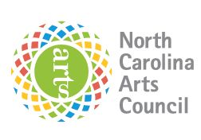
North Carolina Arts Council Artist Support Grant

Sample Grant Award Letter
[ include LAC Logo ]

[Date]
[Full Name]
[Address Line 1]
[Address Line 2]
Dear [Grantee]:

Congratulations! You have been selected as a North Carolina Arts Council Artist Support Grant award recipient. The [Lead Arts Council] received [# of applications] and awarded [# of grant awards].

Attached you will find your grant award packet including your grant contract, reporting requirements, and supplemental documents. Please review the enclosed contract carefully, and sign and return the contract along with your W-9 form. You may return your contract and additional materials by standard mail or fax, or you can scan and e-mail them back to me at [Contact Email Address].

If your project was partially funded, you will be required to complete a revised budget and project narrative. This will allow you to make changes to your project as a result of reduced funding. Please note these changes should not change the intent of the overall project and are subject to approval.

Panelists may have provided comments about some applicants. If you would like to discuss your grant award or the funding panel's comments and suggestions, please call me to schedule an appointment.

We congratulate you on your success and look forward to working with you in the coming year as your project unfolds.

Kindest regards,
[Contact Person and Title]

